Author Guidelines
Author 1¹, Author 2²
¹Corresponding Author; Affiliation; E-Mail; ORCID; Phone Number
²Affiliation; E-Mail; ORCID

Abstract
This document is the manuscript template of Intelligent Methods In Engineering Sciences (IMIENS). Besides being a template this document includes the information about the formatting of your work. This abstract section of the manuscript should be between 100 and 250 words. Keywords should start with bold Keywords title and should not exceed 6 keywords. Each keyword should be separated with comma symbol.
Keywords: parallel computing, real-time systems, compilers
1. Introduction
This document is the manuscript template of Intelligent Methods In Engineering Sciences (IMIENS). With this template we provide the recommended structure and specific styles for the formatting of the manuscript. Author(s) should use these specific styles for each part (for example title, abstract, keyword etc.) of the manuscript. Besides being a template, this document includes the information about the formatting of your work.
The full name(s) of the author(s) should be given. In addition the e-mail address(es), affiliation(s) of all author’s should be provided. The telephone number of the corresponding author should be written.
Abstract section of the manuscript should be between 100 and 200 words.
Keywords should start with a bold “Keywords” title and should not exceed 6 keywords. Each keyword should be separated with comma symbol.
The citations should be given in IEEE Style. Authors can get help from citation management applications (tools) when preparing their papers. The title of the citations section should be “References”. A sample reference list is shown at the end of this document in “References” section.
In text citations should be writeen in square brackets like [1], [2]–[4], [2–4], [5], [6].
Paragraphs should not start with indentation.
2. Writing Equations
Equations should be centered in the page. Equation number should be written inside paranthesis at the right side of the equation, and should be aligned right in the page. A sample equation, Equation 1 is shown below. Equations should be cited with their full names like “as seen in Equation 1”, “as seen in Equations 3 and 4”.
$$\int{\frac{-b±\sqrt{b^{2}-4ac}}{2a}}e^{-iωt}\frac{Δy}{Δx}\frac{∂y}{∂x}\sum{\frac{π}{2}}$$ | (1)
3. Tables and Figures
3.1 Tables
Tables should be centered in the page. Table number and caption should be written above the table as shown in Table 1. Tables should be cited with their full names like “as seen in Table 1”, “as seen in Tables 3 and 4”.

Table 1 Initial Results
Header 1 | Header 2 | Header 3
3 | Data 1 | 10.6
10 | Data 2 | 7.3
3.2 Figures
Figures should be centered in the page. Figure number and caption should be written below the figure as shown in Figure 1. Figures should be cited with their full names like “as seen in Figure 1” or like “as seen in Figures 3 and 4”.

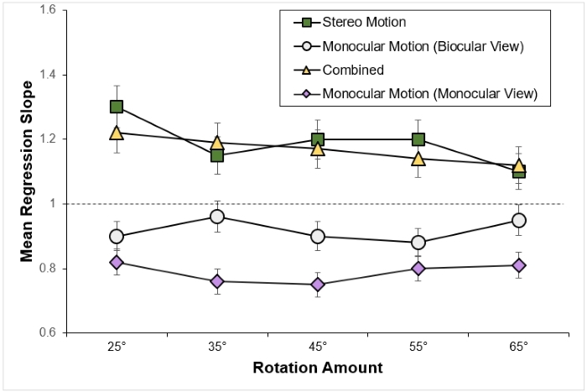
Figure 1 Flow Chart
4. Algorithms, Codes, and Pseudocodes
Algorithms, codes, and pseudocodes should be given in a table structure centered in the page as shown in Algorithm1 and Code 1. The caption should start with Algorithm, Code, or Pseudocode keyword depending on the the content, and also should be cited according to this preference. For example, “as seen in Algorithm 1”, “as shown in Code 1 and 3”.

Algorithm 1 Algorithm Example
1  2  3  4  5 | get the next process  compare the CPU time with the max CPU time  if it is greater than the max CPU time then  make this time the max CPU time  go to line 1

If the line count of the content is very much, and the line width of the content is not large than you may choose to write them in two columns as shown in Code 1.

Code 1 Two Column Example
1  2  3  4  5  6  7 | int main() {  int a = 5;  int b;  b = make_calculation(4);  return a + b;  } | 8  9  10  11  12  13 | int make_calculation(int c) {  int d = 5;  result = c * d;  return result;  }
Acknowledgments
Acknowledgments (people, grants, funds etc.) should be given in this section.
It is mandatory that a statement regarding the contribution rate of the researchers, a statement of support and acknowledgment, if any, and a Conflict of Interest Statement be submitted at the end of the article.
References
After eight and more authors, “et al.” should be used after the first author’s name. Otherwise, the names of all authors should be expressed.
[1] F. J. Cazorla et al., “PROXIMA: Improving Measurement-Based Timing Analysis through Randomisation and Probabilistic Analysis,” Proc. - 19th Euromicro Conf. Digit. Syst. Des. DSD 2016, pp. 276–285, 2016.
[2] R. I. Davis and L. Cucu-Grosjean, “A Survey of Probabilistic Schedulability Analysis Techniques for Real-Time Systems,” Leibniz Trans. Embed. Syst., vol. 6, no. 1, pp. 04:1–04:53, 2019.
[3] J. Abella, D. Hardy, I. Puaut, E. Quinones, and F. J. Cazorla, “On the comparison of deterministic and probabilistic WCET estimation techniques,” Proc. - Euromicro Conf. Real-Time Syst., pp. 266–275, 2014.
[4] C. Wohlin, P. Runeson, M. Höst, M. C. Ohlsson, B. Regnell, and A. Wesslén, Experimentation in Software Engineering. Berlin, Heidelberg: Springer Berlin Heidelberg, 2012.
[5] gem5, “gem5 homepage,” 2018. [Online]. Available: http://gem5.org. [Accessed: 24-Aug-2019].
[6] B. Lesage, D. Griffin, S. Altmeyer, L. Cucu-Grosjean, and R. I. Davis, “On the analysis of random replacement caches using static probabilistic timing methods for multi-path programs,” Real-Time Syst., vol. 54, no. 2, pp. 307–388, 2018.

